CS 540 Fall 2018

Sushma Kudlur Nirvanappa

[9079813292]

CS 540-1: Introduction to Arti cial Intelligence

Homework Assignment # 5

Assigned: 10/4

Due: 10/11 before class

**Question 1: Game Tree Search [50 points]**

Consider the game tree below. Let and r nodes represent nodes belonging to the maximizing and minimizing player respectively.

1. (20 points) Use the minimax algorithm to
2. compute the game theoretical value at EACH node;

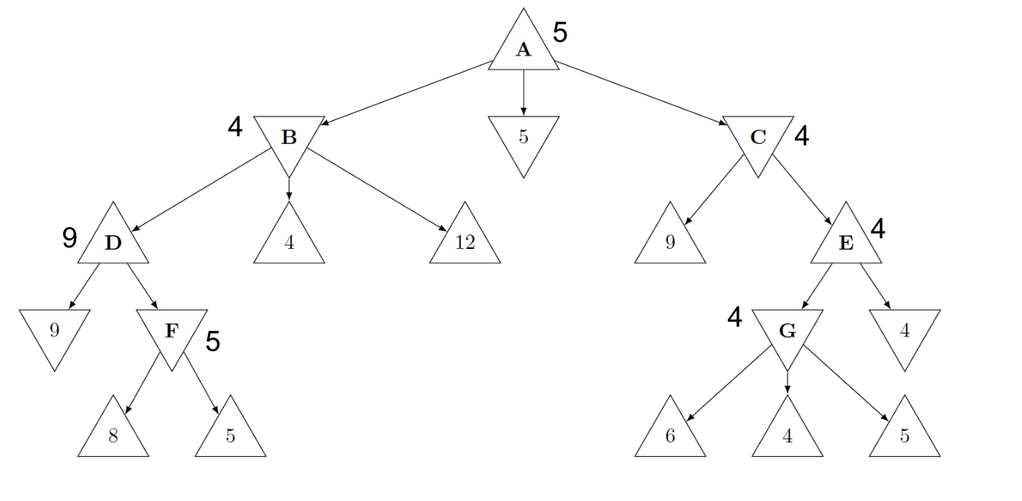

(b). list the set of optimal moves, namely ones that achieve the game theoretical value at the node, for the corresponding player at EACH node.

|  |  |
| --- | --- |
| **Nodes** | **Optimal Path** |
| A | A -> 5 |
| B | B -> 4 |
| D | D -> 9 |
| F | F -> 5 |
| C | 1. C -> E -> G -> 4 2. C -> E -> 4 |
| E | 1. E -> 4 2. E -> G -> 4 |
| G | G -> 4 |

2. (20 points) Use alpha-beta pruning to compute the Minimax value at each node for the same game tree. Assume that nodes are visited from left to right. Show your alpha and beta values at EACH node after the nal time it is visited. Also clearly indicate the subtrees that are pruned (if any).

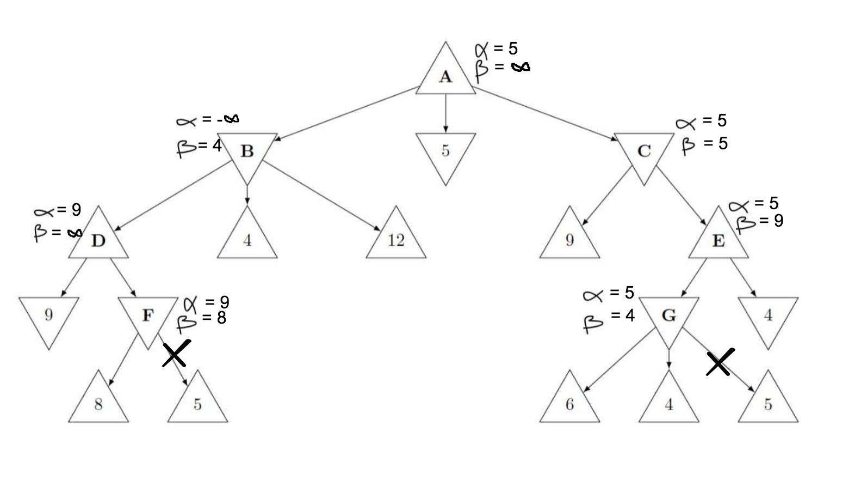

3. (10 points) Does there exist a game tree where minimax and alpha-beta pruning algorithms have the potential to produce different moves? Justify your answer.

There exist no game tree where minmax and alpha-beta pruning algorithms have the potential to produce different moves. Minmax explores all possible moves while alpha-beta pruning algorithm helps to eliminates the paths/moves from which optimal path/move can’t be expected. While both minmax and alpha-beta pruning follow left-to-right approach (here), minmax gives left priority to break the tie and alpha-beta pruning prunes right path once left path is found optimal. This way they both end up getting same optimal path.

**Question 2: Probability [50 points]**

1. (10 points) Consider the two events:

1. Roll two fair dice with a total of seven.

Favorable samples = {1,6}, {2,5}, {3,4}

Permutation of {1,6} = 2

Permutation of {2,5} = 2

Permutation of {3,4} = 2

(F): Total number of favorable samples = 6

Number of possible outcomes of rolling a dice = 6

(T): Total number of sample space (rolling 2 dice) = 6 * 6 = 36

Thus, P(Roll two fair dice with a total of seven) = #(Favorable samples) / # (Total samples) = # (F) / # (T)

= 6 / 36

= 1 / 6

1. Roll three fair dice with a total of seven.

Favorable samples = {1,1,5}, {1,2,4}, {1,3,3}, {2,2,3}

Permutation of {1,1,5} = 6/2! = 3

Permutation of {1,2,4} = 6

Permutation of {1,3,3} = 6/2! = 3

Permutation of {2,2,3} = 6/2! = 3

(F): Total number of favorable samples = 15

Number of possible outcomes of rolling a dice = 6

(T): Total number of sample space (rolling 3 dice) = 6 * 6 * 6 = 216

Thus, P(Roll three fair dice with a total of seven) = #(Favorable samples) / # (Total samples) = # (F) / # (T)

= 15 / 216

Q: Which of these is more likely to happen? Justify your answer by computing the probability of each event.

A: Probability of getting a seven by rolling two dice is most likely to happen than getting a seven by rolling three dice. The above probability also proves the same:

P(Roll two fair dice with a total of seven) = p(A) = 1/6

P(Roll three fair dice with a total of seven) = p(B) = 15/216

This shows, p(A) > p(B)

2. (10 points) John and Robert play a game with a pile of 52 cards. The player who gets the Ace of Hearts wins. John and Robert pick up 2 cards each. John shows his cards to Robert rst, but Johns cards does not contain the Heart Ace. What is the probability of Robert winning?

Let R = Event that Robert will get an Ace of heart.

Let J = Event that John will get an Ace of heart.

Then ¬J = Event that John will not get an Ave of heart.

We have to compute P(R/¬J). Robert has to pick 2 card from the remaining 50 cards as above says that 2 cards that john picked doesn’t have an Ace of heart.

Let A = An event where first pick of card by Robert will be Ace of heart.

Let B = An event where second pick of acrd by Robert will be Ace of heart.

Now, we can define P(R/¬J) = P(A/¬J) + P(¬A,B/¬J)

= 1/50 + P(B/¬A,¬J) * P(¬A/¬J) // By chain rule

= 1/50 + 1/49 * 49/50

= 1/50 + 1/50

= 1/25

Thus, the probability that Robert will get Ace of heart is 1/25 = 0.04

3. (10 points) 1 out of 10000 clover leaves has four leaves. Assuming clover leaves are picked randomly and independently. How many clover leaves does one need to inspect in order to get a four-leaf clover with probability at least 0.9?

Total number of clover leaves (T) = 10000,

Total number of clover leaves that has 4 leaves (FL) = 1

So P(Getting a 4 leaves clover leaf) = P(FL) = 1 / 10000

Hence, P(Not getting a 4 leaves clover leaf) = P(¬FL) = 1 - P(FL)

= 1 - (1 / 10000)

= 9999 / 10000

Now, let ‘n’ be the number of times we have to inspect in order to get a four-leaf clover with probability of at least 0.9.

Probability of not getting a four-leaf clover in those ‘n’ times $= {P(¬FL)^{n}}^{}$

Probability of getting a four-leaf clover within those ‘n’ times $=1- {P(¬FL)^{n}}^{}$

So we have to find ‘n’ value such that the probability is at least 0.9, so mathematically:

$1- {P(¬FL)^{n} ≥0.9}^{}$

$1- {(9999/10000)^{n} ≥0.9}^{}$

$1- {0.9 ≥(9999/10000)^{n}}^{}$

${0.1 ≥(9999/10000)^{n}}^{}$

$log({0.1) ≥log(9999/10000)^{n}}^{}$// Applying log to the base 10 on both sides

${-1 ≥n log(9999/10000)^{}}^{}$

${-1 ≥n(-4.343*10^{-4})}^{}$

${1 ≤n(4.343*10^{-4})}^{}$// Multiplying by -1 on both sides

${n ≥1 / (4.343*10^{-4})}^{}$

${n ≥1 / (4.343*10^{-4})}^{}$

${n≥23024.69 => n≥23025}^{}$

Thus one has to inspect at least 23025 times in order to get a four-leaf clover with a least probability of 0.9.

4. (10 points) There are three cards in an opaque box. The first card is painted black on both sides, the second card is painted red on both sides, and the third card has one side black and one side red. One picks a card randomly and observes one side of this card is black (without seeing the other side). What is the probability that the other side is red?

Let C1, C2 and C3 be the three cards. So, P(C1) = P(C2) = P(C3) = 1 / 3

Let R = Red side of a card, B = Black side of a card.

And we have C1 = {B, B}, C2 = {R, R}, C3 = {B, R}

P(R/C1) = 0, P(B/C1) = 1

P(R/C2) = 1, P(B/C2) = 0

P(R/C3) = ½, P(B/C3) = ½

In overall probability space, we have P(B) = 3/6 = ½ and P(R) = 3/6 = ½

So we have to compute P(R/B) which is probability that second side of a card is red provided that one side of the card is black.

(Eq-1) ----> P(R/B) = P(R,B) / P(B) // Conditional probability

Computing P(R,B) = P(R,B,C1) + P(R,B,C2) + P(R,B,C3)

P(R,B) = 0 + 0 + P(C3) * P(R,B/C3)

= ⅓ * P(R/B,C3) * P(B/C3) // By chain rule

= ⅓ * 1 * ½

= ⅙

Computing P(B) = P(B,C1) + P(B,C2) + P(B,C3)

P(B) = P(C1) * P(B/C1) + P(C2) * P(B/C2) + P(C3) * P(B/C3)

= ⅓ * 1 + ⅓ * 0 + ⅓ * ½

= ⅓ + ⅙

= 1/2

Applying to (Eq-1) = P(R/B) = P(R,B) / P (B)

P(R/B) = (⅙) / (1/2)

= ⅓

Thus the probability of getting a red sided card provided that other side of card is black is ⅓

5.(10 points) Suppose that the probability of the word lottery appearing in a spam email is 42%, and the probability of it appearing in a non-spam email is 5%. If every email received has equal probability of being spam or not spam, what is the probability that an email is spam given it contains the word lottery?

Let S be spam email, NS be non-spam email, L be lottery word in emails

Given P(S) = P(NS) = 50% = 0.5

P(L/S) = 42% = 0.42, Which also means P(¬L/S) = 58% = 0.58

P(L/NS) = 5% = 0.05, Which also means P(¬L/NS) = 95% = 0.95

(Eq-1) ----> We have to compute P(S/L) = P(L/S) * P(S) / P(L)

Lets compute P(L) = P(L,S) + P(L, NS)

= P(L/S) * P(S) + P(L/NS) * P(NS)

= 0.42 * 0.5 + 0.05 * 0.50

= 0.47 * 0.5

Now,applying to (Eq-1) P(S/L) = P(L/S) * P(S) / P(L)

P(S/L) = 0.42 * 0.5 / (0.47 * 0.5)

= 0.42 / 0.47

= 0.8936

So the probability that the given word Lottery is from Spam email is 0.89